Memo to foreign students studying at the Omsk State Agrarian University

1. Subscribe to the International Department group in VK to keep up to date with all changes https://vk.com/omgau_international
2. Apply for an invitation to apply for a visa by e-mail to mezhd.otd@omgau.org
3. Upon entry to Russia, full-time, part-time and correspondence students (graduate students, interns) are required to fill out a migration card and indicate the purpose of entry "Study" (be sure to emphasize in the migration card). Another purpose of entry is a violation of the migration legislation of the Russian Federation.
- Within three days after you have crossed the border as a foreign student at Omsk State Agrarian University, we ask you to send to the e-mail address of the person responsible for admission to classes at the faculty (Appendix 4), information about the arrival of the foreign student (Appendix 1), as well as copies of: passport, migration card with the designated purpose of Study, VMI policy (voluntary health insurance policy).
3. Migration registration is carried out when living in a dormitory - in the sector of registration and passport work of the legal department of the Omsk State Agrarian University of the corresponding campus, when living in the city – the owners of housing. The migration registration of visa citizens is carried out by the International Relations Department. A state fee of 500 rubles is charged for migration registration at the place of stay, and 1,000 rubles for extending the period of temporary stay.
4. Upon check-in to the dormitory, you must present:
- a photocopy of your passport or ID card
- migration card
- voluntary health insurance policy
- 2 photos (3X4)
- a photocopy of the fluorography (in the absence, you can go through and get the result on the day of treatment on campus at Polyclinic No. 4, Sibakovskaya str., 7A)
- a photocopy of the vaccination certificate.
5. Within 90 days from the date of arrival, students must undergo a medical examination at established medical organizations (Appendix 2) and mandatory state fingerprint registration. The average price for a set of services is 6000 rubles.
The algorithm for passing a medical examination and fingerprinting in the attached document (The algorithm for passing a medical examination and state fingerprint registration for foreign students).
6. Please note that the availability of an insurance policy is mandatory for all foreign citizens residing in the territory of the Russian Federation. Universities, together with insurance companies, have developed special programs for students, clause 5.1 of Article 5 of Federal Law No. 115-FZ dated 07/25/2002 (as amended on 12/29/2022) "On the Legal status of Foreign Citizens in the Russian Federation" (Appendix 3). The average price range for a voluntary health insurance policy in the Omsk region is from 2000 to 7,500 rubles.
7. All foreign students must necessarily subscribe to the group of the international department of Omsk State Agrarian University on the Vkontakte social network, where foreign students are constantly informed about changes in legislation. https://vk.com/omgau_international

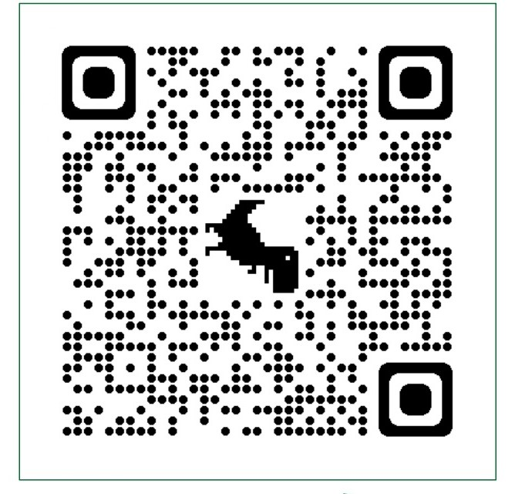

Appendix 1

Information about the arrival of a foreign student in
FSBEI HE Omsk SAU

Full name
Citizenship
Date of birth (dd.mm.yyyy)
Faculty and group
The exact date of arrival
The address of the place of residence in the territory of the Russian Federation (street, house number, apartment (room) number)
Phone number operating in the territory of the Russian Federation

* In accordance with clause 5.1 of Article 5 of Federal Law No. 115-FZ of 07/25/2002 (as amended on 12/29/2022) "On the Legal Status of Foreign Citizens in the Russian Federation" (with amendments and additions, intro. effective from 01/11/2023), all foreign citizens temporarily entering the territory of the Russian Federation are required to have a voluntary medical insurance contract (VMI policy) valid on the territory of the Russian Federation, concluded with an insurance company or with a foreign insurance company entitled, in accordance with insurance legislation, to carry out voluntary medical insurance in the Russian Federation.

Appendix 2

Medical organizations that issue certificates and medical examination reports as of 09/10/2025

Name of the medical organization | Address | Cost, rub.
"Medina" clinic for medical examination of foreign citizens | 172B 10 let Oktyabrya str. | 4100
Clinical and Diagnostic Medical Center "Zdorovie" | 157 Oktiabrskaia Street | 4500

The state fingerprint registration is carried out at the Federal State Unitary Enterprise "Passport and Visa Service" of the Ministry of Internal Affairs of the Russian Federation in the Omsk region, located at the address: Omsk, 21 Liza Chaikina street. Tel.: 955-521; 8-913-967-49-90. Opening hours: Mon.-Thu.: 9:00-18:00, Fri.: 9:00-16:45, with lunch break: 13:00-13:45; Sat.-Sun.: day off.

Appendix 3

Health insurance programs for students
Omsk State Agrarian University on 09/10/2025

The VMI package | Organization | Contact information | Price
Student of Omsk State Agrarian University  for 12 months.  Insurance amount  1 million 150 thousand rubles –  1 million 150 thousand rubles .  Service in Polyclinic No. 4,  7A Sibakovskaya street | Insurance Company "PARI"  The VMI policy can be issued online at the link: https://skpari.ru/private-client/student/forms/first_step?utm_source=IntVologina&utm_medium=partner&utm_campaign=polis-student   | Address:  25 Marshal Zhukov str., office 7  Phone: 30-17-00  8-913-960-45-70 | 2000 – 12,000 rubles .
for correspondence students and interns  for 1 month |  |  | 500 rubles.
Student of Omsk State Agrarian University  for 12 months.  The insurance amount is 500 thousand rubles. | Capital LIFE  A VMI policy can be issued online:  Send information about yourself to WhatsApp at +79139695264  (Full name, date of birth, university, residential address)  and within 5 minutes you will receive  an electronic policy | Address:  80 Frunze St., office 849  (Flagman mall)  Phone: 89139695264 | 2,300 - 5,000 rubles .
For correspondence students and interns  for 3 months  Insurance amount  500 thousand rubles . |  |  | 900 rubles.
For full-time and part-time students, interns for a period of 1 month or more.  up to 12 months.  The insurance amount is from 500 thousand rubles to 1 million rubles. | ROSGOSSTRAKH Insurance Company  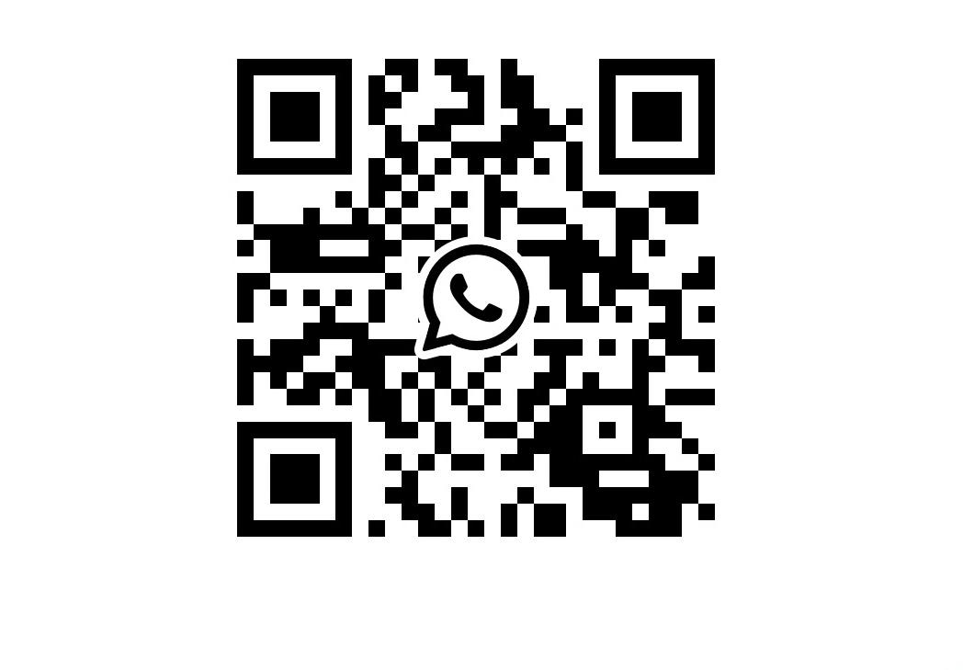 | Insurance Manager Daria Borisovna Paletskaia | 800 - 2800 rubles .
The insurance amount is from 750 thousand rubles to 2 million rubles. |  | The head of the direction is  Sut Maria Alexandrovna | 900 -3400 rubles .
"VMI-Student"  The insurance amount is 620 thousand. | Insurance House "VSK"   | Address:  6 Krasina str.,  Phone: 8 (3812) 27-55-27,  ext. 40356  +7-908-808-88-85 | 2500 rubles.
"VMI-Student"  The insurance amount is 1 million rubles. |  |  | 3500 rubles.

Students have the right to choose an insurance company on their own, in this case, the VMI policy must comply with legal requirements and include mandatory: the insured amount is not less than 100 thousand rubles, planned medical care (the insured amount is not less than 500 thousand rubles, specialized medical care in an emergency form, repatriation (the insured amount is not less than 500 thousand rubles).

Appendix 4

E-mail addresses of those responsible for admission of foreign students to classes at the Omsk State Agrarian University on 09/10/2025

№ | Structural division | Email
1 | Agrotechnological Faculty | yuv.frizen@omgau.org
2 | Faculty of Agrochemistry, Soil Sciences, Ecology, Environmental Engineering and Water Resources Exploitation | yuv.slabko@omgau.org
3 | Faculty of Veterinary Medicine | es.dochilova@omgau.org
4 | Faculty of Land Management | ev.kotsur@omgau.org
5 | Faculty of Technical Service of Agroindustrial Complexes | ob.smirnova@omgau.org
6 | Faculty of Zootechny, Commodity Science and Standardisation | nt.dyuzhikova@omgau.org
7 | Faculty of Economics | en.topekha@omgau.org
8 | University College of Agribusiness | ma.roon@omgau.org
9 | Department of Postgraduate and Doctoral Studies | asp.otd@omgau.org
10 | Faculty of Higher Education at Tara Branch | dek_atf_tfomgau@mail.ru

